REFACTORING TO DESIGN PATTERNS

In this assignment, you are required to use the code for the movie rental application and add the following features:

1. You are required to modify the code to make the function of computing rental prices into a strategy design pattern (That is, you will have strategy classes to compute rental prices).
2. You are required to modify the code to make the function of computing frequent rental points into a strategy design pattern (That is, you will have strategy classes to compute frequent rental points).

## Overview of Approach

Each rental will calculate the rental cost and rental points based on their calculation strategies respectively:

* CostCalculator: This strategy will calculate rental cost for each rental including late fee. Each type of movie such as Regular, New Release, or Children has its own strategy to calculate rental cost.
* PointsCaculator: This strategy will calculate rental points for each rental. Rental points are calculated based on two strategies: New Release vs. Standard rental.

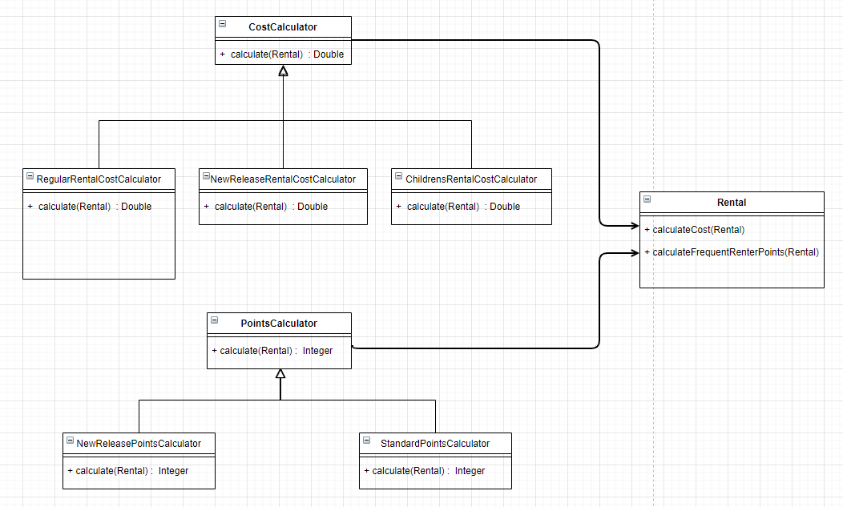

With these strategies approach, we were able to move the Switch case from Customer class to Rental class and simplify the statement method in Customer class. The Rental class now handles rental cost and rental point which it should be doing. The rental cost and rental point calculation strategies make it easy to understand the calculation methods. These changes make the final code more readable and maintainable compare to the original code.